OOP ASSIGNMENT

Charles Muema BSCIT-05-0051/2025

Library Management System

This C++ program implements a simple library management system using only the <iostream> library. It is designed to manage a single library and allows the user to add, display, find, and delete books through a menu-driven interface.
The system stores book titles in a fixed-size two-dimensional character array, where each row represents one book title. A global variable keeps track of how many books are currently stored in the library. This approach avoids using advanced libraries and helps demonstrate how data can be managed manually in memory.
The addBook function allows the user to enter a new book title and stores it in the array if space is available. The displayBooks function lists all the books currently in the library along with their positions. The findBook function searches for a book by comparing the entered title character by character with the stored titles. The deleteBook function removes a book by shifting all remaining books one position forward to fill the gap.
The main function displays a menu that repeatedly prompts the user to choose an action until they decide to exit the program. Each menu option calls the corresponding function to perform the requested operation.
Overall, this program demonstrates basic concepts such as arrays, functions, loops, and user input/output in C++, making it suitable for beginners learning how simple management systems work.

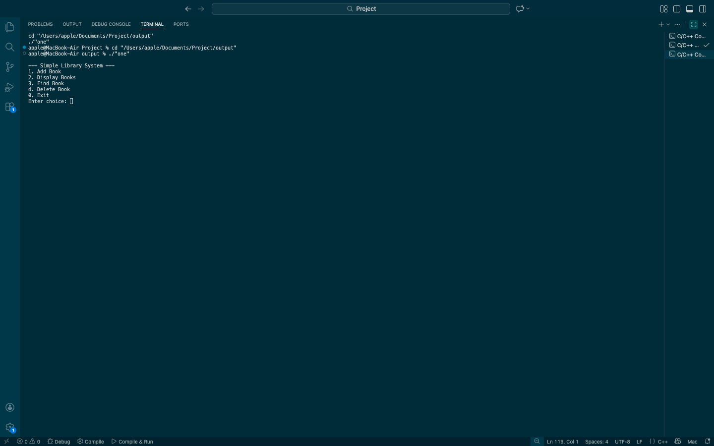
Test Case

This system is used by selecting options from the menu displayed on the screen. When the program starts, the user is shown a list of numbered choices. Selecting option 1 allows the user to add (save) a new book by entering its title, which is then stored in the library. Selecting option 2 displays all the books currently saved in the system. Selecting option 3 is used to find a specific book by typing its title, and the system searches for it in the library. Selecting option 4 allows the user to delete (remove) a book by entering its title. Selecting option 0 exits the system and ends the program.

GitHub URL= https://github.com/Mw-ema/Library-Managment-system-project.git

